**Hotel information**

We suggest that you choose **Futian Shangri-la, Shenzhen** where the Forum shall take place.

**Group Code is ORG150119A for room booking. Reservation should be made by 10th Jan. 2019**

The negotiated price is:

|  |  |  |  |
| --- | --- | --- | --- |
| Room Type/Rate: | Room Category | **Single Room Rate**(included 1 Breakfast and service charge) | **Double Room Rate**(included 2 Breakfast and service charge) |
| All prices are in RMB (10% service charge and 6% VAT included) | **Deluxe Room** | **RMB 1,250 nett** per room per night | **RMB 1,350 nett** per room per night |

Wireless internet access provided.

Please kindly be noted the booking link steps as following:

**Website Link Booking**

Chinese

<http://www.shangri-la.com/reservations/booking/sc/index.aspx?hid=SLFT&group_code=ORG150119A&check_in=20190115&check_out=20190118>

English

<http://www.shangri-la.com/reservations/booking/en/index.aspx?hid=SLFT&group_code=ORG150119A&check_in=20190115&check_out=20190118>

Booking Steps as following,

1. Pls. select the link as your language request.
2. Click into Shangri-La Group Booking website, and make sure the" Corporate/special Rate (Optional)" is **Group** and the code is **ORG150119A** as below,

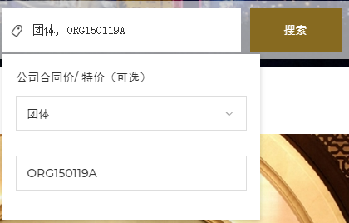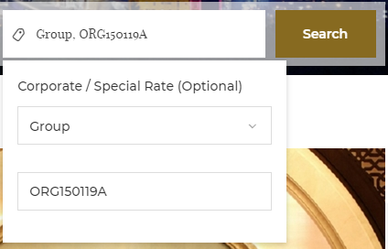

1. 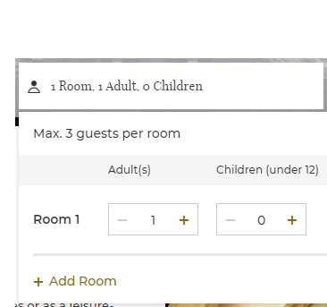Pls. choose the date and room no. of what you need,

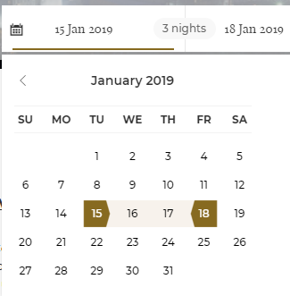

1. Pls. click “Search” and go into the room type page. Then pls. choose what room type you want.
2. Reserved guest room should be guaranteed by credit card and pls. click “Cancellation Policy” and review it.

**Kindly Remind,**

* The code for the special group rate is **ORG150119A**
* **The special rate is only for 15-18 Jan, 2019 three nights in total.**
* **If booking date is different than 15-18 Jan, please send email or contact hotel directly.**
* If there is no guests available on the booking link when you book the rooms, pls.do not hesitate to contact Futian Shangri-La, Shenzhen Reservation to check if any guest rooms available and the contact way as below,

**E-mail address:** **resteam.slft@shangri-la.com**

**Reservation Hot Line:** **(86 755) 2151 3929**

Remarks:

Room booking depends on hotel room availability. All Guest Room reservations shall be guaranteed by delegate’s credit card at the time of booking. Reservation if cancelled exceeding 4pm on 10 Jan, 2019 (hotel’s local time) will be subjected to full charge for the whole duration of the stay.

After check in, any early departure will be resulted in booking nights room charge.

**Accommodation Details:**

Futian Shangri-la, Shenzhen

4088 Yi Tian Road, Futian District, Shenzhen, 518048 China

Phone: (86 755) 8828 4088

E-mail: shenzhenfutian@shangri-la.com

**How to reach Futian Shangri-la, Shenzhen?**

Futian Shangri-La, Shenzhen, is only a 30-minute drive from the Shenzhen Bao'an International Airport. Taxis, public buses and limousine services can be found on the ground floor of the domestic and international arrivals halls.

Arrival and departure limousine services are also available to and from Hong Kong International Airport. The journey between the airport and the hotel takes approximately one to two hours (subject to traffic conditions and the amount of people at the airport).

Airport Connections

There are several options to reach Futian Shangri-La, Shenzhen. Guests can choose between hotel limousine pick-up and taxi.

**Hotel Limousine**

You can book a limousine pick-up by providing your flight details and estimated time of arrival when booking online.

Please make your booking at least one day in advance

Hotel Limousine Charges

Shenzhen Bao'an International Airport

|  |  |
| --- | --- |
| Car Type | Charges |
| Mercedes Benz S300 | [RMB 750](http://www.shangri-la.com/shangrila/currency-converter/RMB/499) |
| Buick 7-seater Van | [RMB 600](http://www.shangri-la.com/shangrila/currency-converter/RMB/599) |
| 23-seater Coaster | [RMB 1000](http://www.shangri-la.com/shangrila/currency-converter/RMB/899) |

Hong Kong International Airport

|  |  |
| --- | --- |
| Car Type | Charges |
| Mercedes Benz S300 | RMB 2000 |

Complimentary Wi-Fi access is available in the limousine

**Taxis**

Taxis in Shenzhen are plentiful and affordable. Flagfall is RMB 10 plus RMB 4 for fuel surcharge. Expect higher fares between 11pm and 6am.

**Map**

