**Hotel information**

We suggest that you choose **Shangri-la Hotel, Guangzhou** where the Forum shall take place.

Please send “Hotel Reservation Form” by mail directly to the hotel before Jan 16, 2018.

Tel: (86 20) 8917 6011

E-mail: resteam.slpg@shangri-la.com

Group Code: OAM310118 for room booking.

The negotiated price is:

|  |  |  |  |
| --- | --- | --- | --- |
| Room Type/Rate: | Room Category | **Single Room Rate**(included 1 Breakfast and service charge) | **Double Room Rate**(included 2 Breakfast and service charge) |
| All prices are in RMB (10% service charge and 6% VAT included) | **Deluxe Room** | **RMB980nett** per room per night | **RMB1080nett** per room per night |
| **Deluxe River View Room** | **RMB1080nett** per room per night | **RMB1180nett** per room per night |

Wireless internet access provided.

Please make reservation before **16th Jan. 2018**; otherwise any required room with negotiated price will be subjected to availability in the hotel.

**Accommodation Details（酒店地址）:**

Shangri-la Hotel, Guangzhou

广州香格里拉大酒店

No.1 Hui Zhan Dong Road, Hai Zhu District, Guangzhou, 510308, China

中国广州市海珠区会展东路1 号 邮政编码 510308

T:(86 20) 8917 8888

F:(86 20) 8917 8899

http://www.shangri-la.com/cn/guangzhou/shangrila/contact-us/

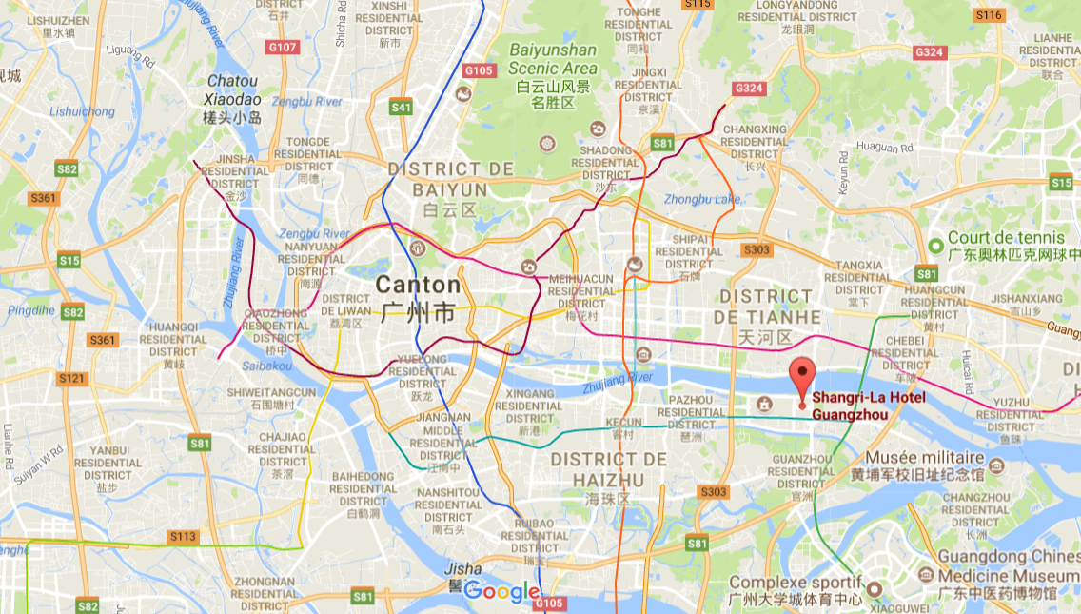

**How to reach Shangri-la Hotel Guangzhou?**

Shangri-La Hotel, Guangzhou, is approximately 45 minutes by car from Guangzhou Bai Yun International Airport and 30 minutes by car from either Guangzhou East Railway station for Guangzhou-Kowloon Express Line, or Guangzhou South Railway Station, which provides high-speed bullet train services linked with major cities in central and northern China.

Airport Connections

There are several options to reach Shangri-La Hotel Guangzhou. Guests can choose among taxi, hotel limousine pick-up and shuttle bus.

**Taxi**

Taxis can be found on the ground floor of the domestic and international arrival halls, which are metered. The fare between Guangzhou Bai Yun International Airport and the hotel generally costs around [RMB 180](http://www.shangri-la.com/shangrila/currency-converter/RMB/120) (approximately [USD 25](http://www.shangri-la.com/shangrila/currency-converter/USD/15)) per journey (inclusive of toll fee).

**Hotel Limousine**

You can book a limousine pick-up by providing your flight details and estimated time of arrival when booking online.

Alternatively, you can also contact us directly by calling (86 20) 8917 8888.

Please make your booking at least one day in advance.

Hotel Limousine Charges

|  |  |
| --- | --- |
| Car Type | Charges |
| Audi A6 | [RMB 750](http://www.shangri-la.com/shangrila/currency-converter/RMB/499) |
| Buick GL8 (6-seater) | [RMB 850](http://www.shangri-la.com/shangrila/currency-converter/RMB/599) |
| Mercedes Benz E-Class | [RMB 800](http://www.shangri-la.com/shangrila/currency-converter/RMB/899) |
| Mercedes Benz S-Class | [RMB 1,300](http://www.shangri-la.com/shangrila/currency-converter/RMB/888) |
| Toyota Coaster (23-Seater) | RMB1,600 |

Complimentary Wi-Fi access is available in the limousine

Please note that hotel provides limousine service to/from Guangzhou East Railway Station, which starts as low as RMB 450 net per car, per way.

**Hotel Shuttle Bus**

A complimentary hotel shuttle bus is available to and from the city's key locations. Please check link of shuttle bus schedule.

<http://www.shangri-la.com/uploadedFiles/Shangri-la_Hotels/Shangri-La_Hotel,_Guangzhou/20160920%20final.pdf>