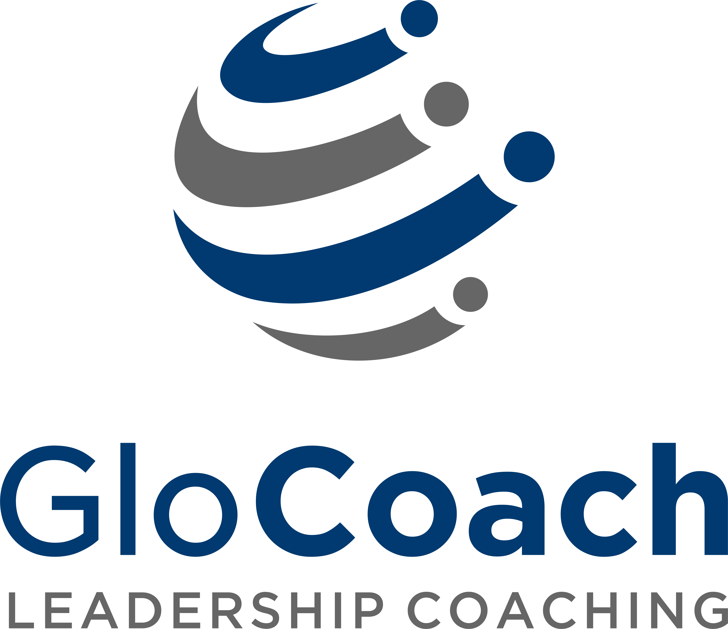

GloCoach, part of International Learning Enterprise, is a new global leadership coaching business. We disrupt the traditional executive coaching industry by leveraging technology to breakdown the barriers of geography, time difference and organization hierarchy, so we could bring together the best coaches worldwide and deliver 1 on 1 live coaching on our cloud-based Learning Management System. Today, our clients are in more than 50 cities throughout Asia. We serve Chinese and foreign multinational companies with extensive people development solutions to fully support organizational goals with measurable results that matter. Our plan is to expand to international markets in the US and Europe.
Our website: http://www.ile-china.com/glocoach/coaches-en.php

Do you want to be part of this pioneering edtech company transforming global executive education on a global level?

BD Manager
Full-time staff

Description of Role
We are looking for energetic, self-motivated BD to join our fast growing team. You will focus on expanding the client base; primary targets include HRDs and senior line managers, helping them to diagnose organizational development needs and gaps. This is a revolutionary opportunity to work with industry thought leaders in a dynamic environment, expand your professional skills and rapidly develop your career.

Specific responsibilities include:

- Expand the market, look for senior level people/HR leads to understand their key pain points and developmental plans for their business, and close deals through consultative selling our coaching solution.
- Convert to signed customers through nurturing long-term relationship and winning trust by help solving problems and gaining respect as the industry golden benchmark.
- Assist customer in understanding our brand, our product experience and systems better to ensure customer retention
- BD should get feedback from customer periodically as part of after-sales service and gauge feedback as input to further develop the service solution.

Qualifications
- Work experience in B2B sales and /or customer service;
- Work ideally in organizations as a HR service vendor , preferably in coaching, training, consulting industries;
- Bachelor degree or above, Marketing and related majors are preferred;
- Confident, result oriented and deliver results
- The ability to engage and nurture customer relationships to efficiently move through the sales funnel;
- Adapt to international working environment, fluent in Chinese and are comfortable speaking English;
- Demonstrates Initiative, clear thinking, sense of responsibility.
Language
Fluent both English and Chinese
Additional Information
- Location: Jingan, Shanghai
- Start Date: immediate
Apply
- Resume
- Cover Letter
- Send your application to jobs@glocoach.com

GloCoach 作为International Learning Enterprise （ILE）的一部分，是一个新的全球领导力发展专家。我们颠覆了高管教练行业的传统，运用科技段打破了地域、时区和组织层级的壁垒。这也使得我们能够将全世界最优秀的教练在我们的云端学习管理系统上聚集起来，提供一对一实时教练服务。今天，我们的客户分布于超过全球50个城市。在中国，我们为数百家中外跨国企业提供了广泛的人力开发的解决方案，全力支持企业与个人支持，并且有可量化的结果。我们的计划是将要扩大和发展我们在美国、欧洲的国际市场。

我们的网站：http://www.ile-china.com/glocoach/coaches-en.php

你想成为这个领先的教育科技公司的一部分，在全球层面上改变高管教育吗？
商务拓展 经理
全职员工

我们在寻觅一位积极、有上进心且注重细节的BD伙伴加入我们这个茁壮成长的团队。
你将专注于扩展客户群；主要包括HRD和高级经理，帮助他们判断组织发展需求和差异。这是一个绝佳的机会，你可以在充满活力环境中与行业中的思想领袖同行，拓展你的专业技能并迅速发展您的事业。

具体职责包括：

- 拓展市场，联系高层人员/人力资源/管理团队，并全面了解他们对业务的核心顾虑和发展规划，通过向他们销售我们的教练服务完成交易。
- 通过帮助客户解决问题获得获得他们的尊重，让他们将我们视为行业最佳标准，今儿通过培养长期关系获得信任，将潜在客户转化为签约客户。
- 帮助客户更好地了解我们的品牌、产品使用体验和体系以留住客户。
- 定期对客户进行回访，了解客户对售后的需求并反馈给客服，提高售后服务质量；
职位要求：
- 有B2B销售或客服工作经验
- 有教育咨询行业、客服、销售经验者优先；
- 本科及以上学历，市场及相关专业优先
- 自信、结果为导向
- 具有与人力资源专业人员打交道的销售经验者优先
- 与客户建立、维持并培养长期良好关系的能力，有效地运用销售
- 适应国际化的工作环境，中文流利且能够适应说英语
- 做事积极主动，思维清晰，富有责任心

语言
流利的中英文

其他信息
办公地点：上海市静安区
开始时间：尽快

申请方式
请发邮件（包括求职信和简历）至jobs@glocoach.com

