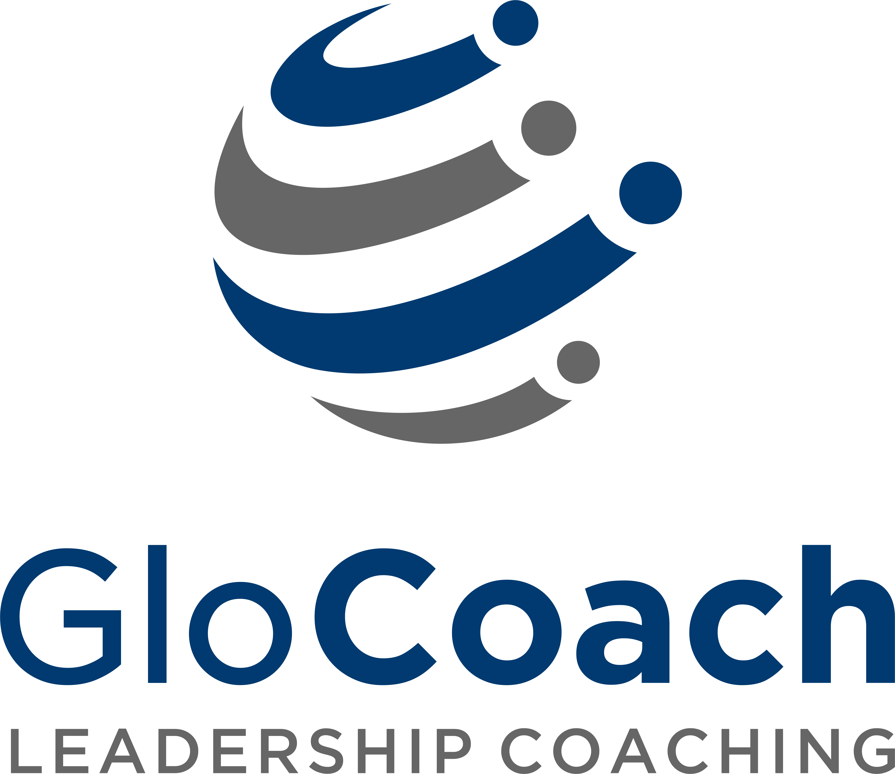

GloCoach, part of International Learning Enterprise, is a new global leadership coaching business. We disrupt the traditional executive coaching industry by leveraging technology to breakdown the barriers of geography, time difference and organization hierarchy, so we could bring together the best coaches worldwide and deliver 1 on 1 live coaching on our cloud-based Learning Management System. Today, our clients are in more than 50 cities throughout Asia. We serve Chinese and foreign multinational companies with extensive people development solutions to fully support organizational goals with measurable results that matter. Our plan is to expand to international markets in the US and Europe.
Our website: http://www.ile-china.com/glocoach/coaches-en.php

GloCoach 作为International Learning Enterprise （ILE）的一部分，是一个新的全球领导力发展专家。我们颠覆了高管教练行业的传统，运用科技段打破了地域、时区和组织层级的壁垒。这也使得我们能够将全世界最优秀的教练在我们的云端学习管理系统上聚集起来，提供一对一实时教练服务。今天，我们的客户分布于超过全球50个城市。在中国，我们为数百家中外跨国企业提供了广泛的人力开发的解决方案，全力支持企业与个人支持，并且有可量化的结果。我们的计划是将要扩大和发展我们在美国、欧洲的国际市场。

我们的网站：http://www.ile-china.com/glocoach/coaches-en.php

Do you want to be part of this pioneering edtech company transforming global executive education on a global level?
你想成为这个领先的教育科技公司的一部分，在全球层面上改变高管教育吗？

Marketing Specialist
市场专员
Full-time staff
全职员工

Keywords: cooperation, communication, marketing, plan, activity, events
关键词: 协调 沟通 营销 策划 活动

Key Responsibilies:
1. According to the business development plan of various innovative products, to make the marketing strategy
and plan of sub-market products;
2. Responsible for planning product marketing activities and organizing the promotion for innovative products;
3. Assist overseas markets to develop local product marketing projects, including assist, guide and co-ordinate.
4. Responsible for promotion and implementation plan for product campaign, follow up publicity and
effectiveness analysis, assist in meeting project expectations.

主要职责描述：
1. 策略制定：依据公司创新产品的业务发展规划，制定境外各分市场产品营销策略；
2. 活动策划：策划创新产品营销活动，并负责项目落地执行、宣传和运营；
3. 统筹项目：协助、指导境外市场开展本地产品营销项目，统筹项目；
4. 效果分析：制定产品营销项目推广计划和实施方案，跟进宣传落地并进行成效分析，协助各分市场达到预期。

Job Qualifications:
1. Full-time BA/BS degree
2. Minimum 2-3 years of working experience in marketing function at banks, Internet companies, international
companies, including project planning, execution, results analysis etc.
3. Strong capabilities in multi-project management, data analysis, resources integration, proposal & reporting, creative
design and market sensitivity.
4. Fluent in EN and CN, be good at communication and writing, communicate with collaborate
organization independently.

任职要求：
1、全日制本科及以上学历。
2、具有2-3年以上银行、互联网公司、跨国企业的产品或市场营销经验，具备国际性公司总部工作经验者为
佳。
3、具备较强的多项目管理能力、数据分析能力、资源整合能力以及较强市场敏感性。
4、中英文流利、沟通及写作能力强，可与合作机构独立交流谈判。

Language
语言
Fluent both English and Chinese
中英文流利

Additional Information
公司信息
- Location: Jingan, Shanghai
地理位置：上海市，静安寺附近
- Start Date: immediate
开始时间：尽快
Apply
所需提供资料
- Resume
个人简历
- Cover Letter
求职信
- Send your application to jobs@glocoach.com
- 请发邮件（包括求职信和简历）至jobs@glocoach.com

