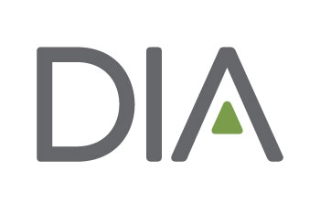

**Half Day and Full Day Preconference Workshop Abstract Form**

Please use this form to prepare your preconference workshop abstract. This will help ensure that you have all of your required information available when you submit your abstract. All abstracts must be submitted online by the designated deadline.

Should you have questions regarding the abstract submission process, please contact [erning.ning@DIAglobal.org](mailto:erning.ning@DIAglobal.org)

**Total number of instructors including authors**:

**Half Day or Full Day**

**Level of Difficulty (Select one):**

O Basic: Appropriate for individuals new to the topic/subject area.

O Intermediate: Appropriate for individuals who already have a basic understanding of the topic/subject

area.

O Advanced: Appropriate for individuals with an in-depth knowledge of the topic/subject area.

**Learning Objectives (400 character limit, including spaces):** Please provide 2-3 learning objectives that clearly explain what participants should be able to do after attending this event. Click [here](http://www2.diaglobal.org/~/media/2F636B395C4A45019A01C3EDC05E31E1.ashx) for a list of suggested verbs to create these objectives.

*Insert details here*

**Target Audience (450 character limit, including spaces):** This short course is designed for:

*Insert details here*

**Overview (2000 character limit, including spaces):** Please provide an Overview description describing the Pre-conference Workshop.

*Note: Half Day Workshop consists of 3 hours and 30 minutes of instruction and Full Day Workshop provides 7 hours and 30 minutes of instruction time*

*Insert details here*